**Assignment 3**

1. Create variables to store your first name, last name and year of birth. Place the following text: "Hi, my name is _____________, I'm _____ years old and I'm learning JavaScript".

Use the current year to calculate your age.

1. Try to recreate the design given in the attached images ‘question2.png’

The Required color code are –

Green - #60BA62

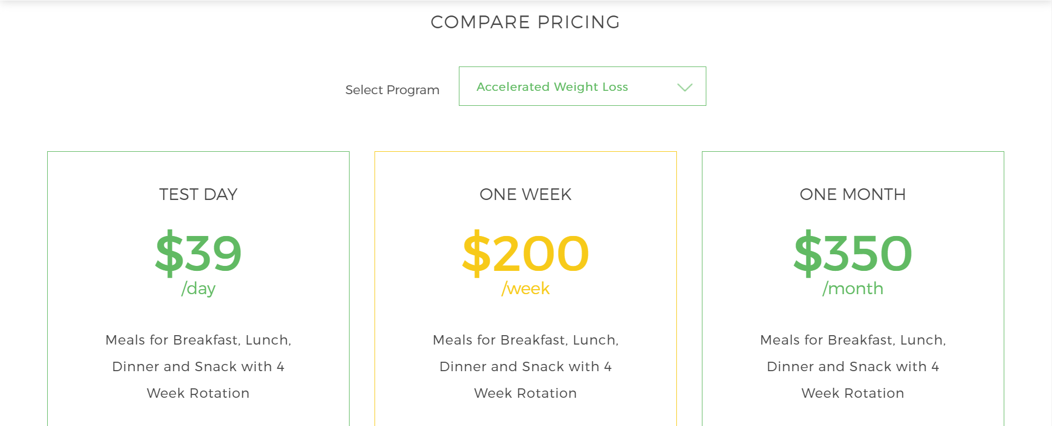

Yellow - #F7CA19



Top part Green - #60BA62

Bottom part Green - #429C44

**All the required images are provided in the zip folder**